Task 3: AEM

1.Create A new component which have news title(should print as h2),

news detail(<p>), published date, source create this component using

sling model.

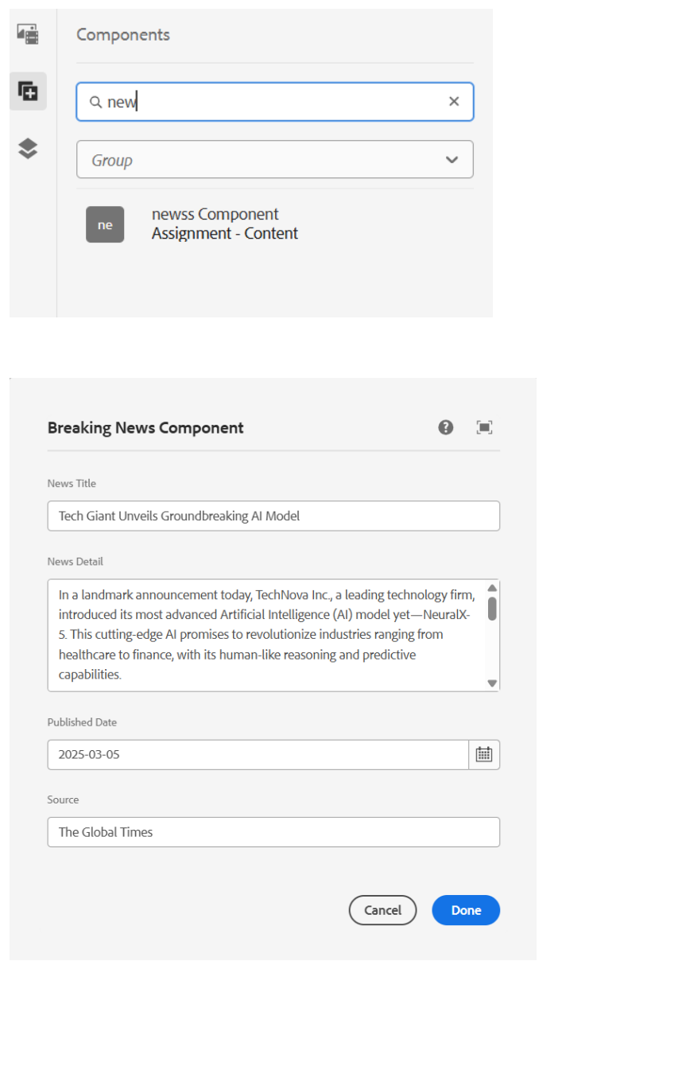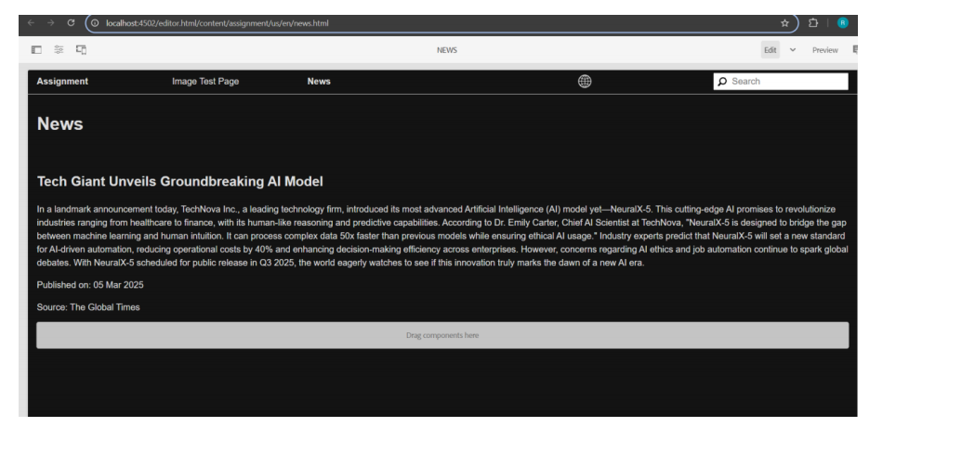

.2.Create multi field component(multiple news) using sling model

fields: title of new and source of news

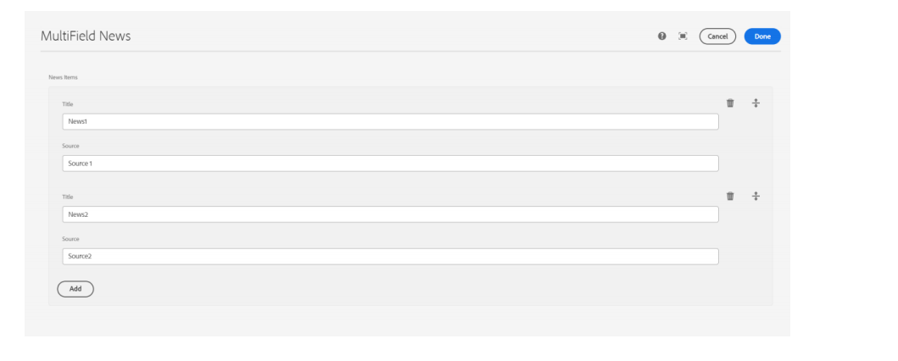

3.Create clientlibs for news component

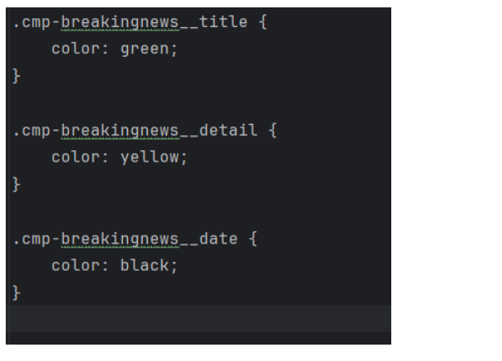

4.Apply Green colour to the heading(h2) and yellow colour to news

detail(<p) and date should be black in colour.

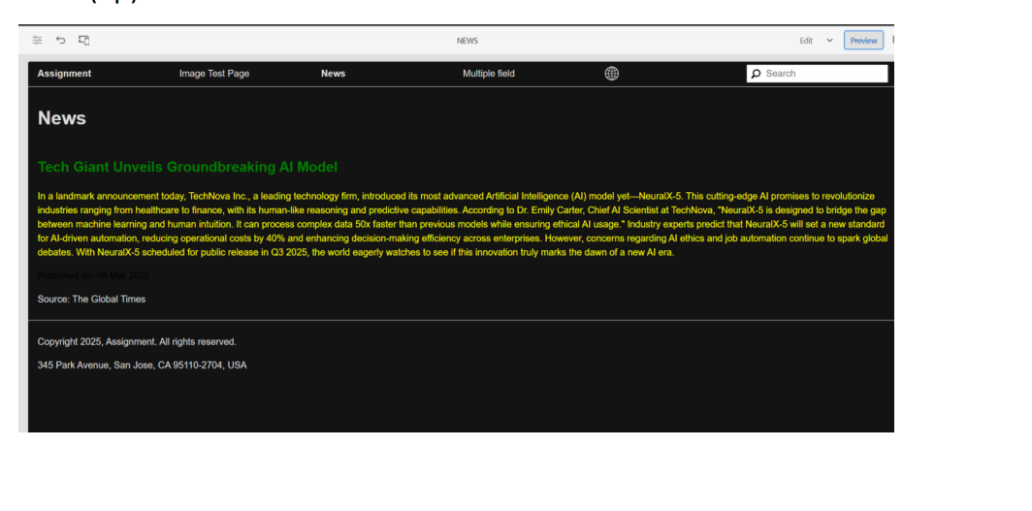

5.Add Component style to add custom style name (cop-news

component) in news component

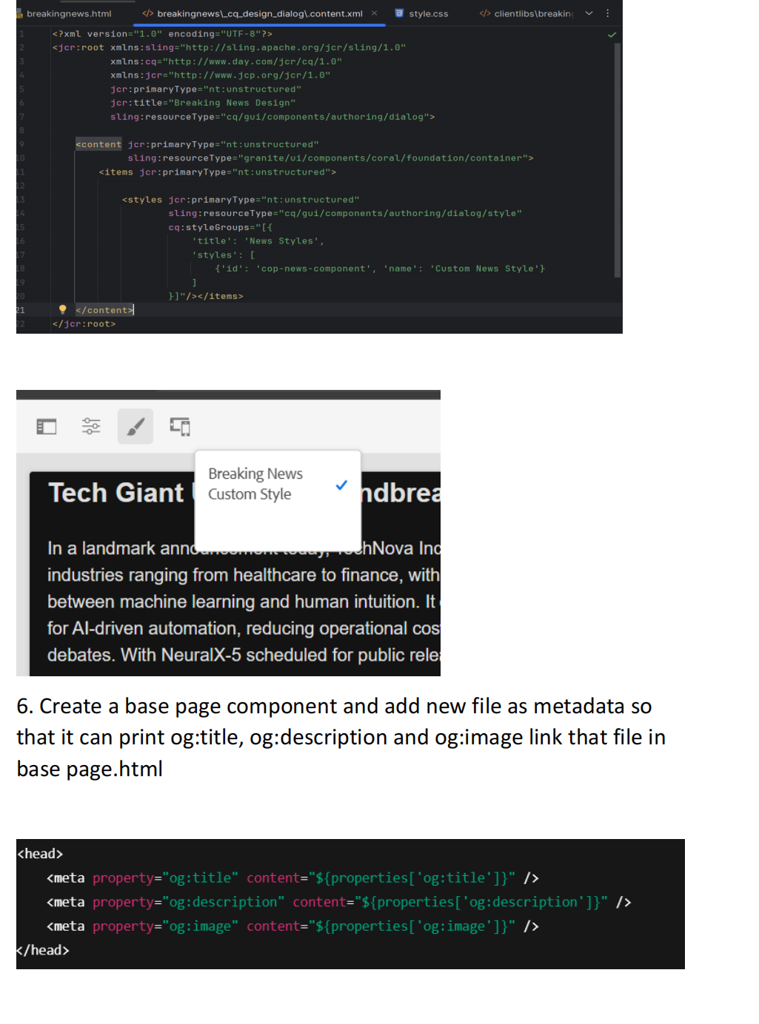

7.Create custom page properties saying Global properties and 3 fields

should be there as og:title, og :description and og:image path.

**dialog.xml**

<jcr:root xmlns:jcr="http://www.jcp.org/jcr/1.0"

xmlns:sling="http://sling.apache.org/jcr/sling/1.0"

jcr:primaryType="cq:Dialog"

cq:dialogMode="floating">

<content jcr:primaryType="nt:unstructured">

<items jcr:primaryType="nt:unstructured">

<ogTitle

jcr:primaryType="nt:unstructured"

sling:resourceType="granite/ui/components/coral/foundation/form/textfiel

d"

fieldLabel="OG Title"

name="./ogTitle"/>

<ogDescription

jcr:primaryType="nt:unstructured"

sling:resourceType="granite/ui/components/coral/foundation/form/textare

a"

fieldLabel="OG Description"

name="./ogDescription"/>

<ogImage

jcr:primaryType="nt:unstructured"

sling:resourceType="granite/ui/components/coral/foundation/form/textfiel

d"

fieldLabel="OG Image"

name="./ogImage"/>

</items>

</content>

</jcr:root>

8. What is extraclientlib add it this multi field component

ExtraClientLibs is a property in AEM that allows additional client

libraries (CSS/JS) to be included dynamically for a component without

modifying the component's default client libraries.

Why Use extraClientLibs?

•

Helps extend functionality without modifying core component

clientlibs.

•

Useful for adding custom JavaScript or styles specific to a

component.

•

Allows separation of concerns, keeping core and additional

scripts/styles modular.

•

Makes debugging and maintenance easier by loading external

scripts as needed

News Component Development using Sling Model News Component Development: The news component was developed using a Sling Model and includes the following fields: • News Title (Rendered as

## in green color) • News Detail (Rendered as

**in yellow color) • Published Date (Displayed in black color) • Source The Sling Model ensures that these fields are dynamically retrieved and displayed in the component. Multi-Field News Component: A multi-field component was created to accommodate multiple news entries dynamically. This component consists of: • A repeatable structure allowing multiple news entries • Fields for News Title and Source This implementation allows content authors to add multiple news articles within a** single instance of the component.

Clientlibs for News Component : Clientlibs were implemented for styling the news component. The following styles were applied: • Heading (h2): Green color • News Detail (

): Yellow color • Published Date: Black color The styles were included in the component using AEM's Clientlibs mechanism.

Custom Component Style: A custom style named cop-news-component was added to the component, allowing content authors to apply predefined styling easily. Base Page Component and Metadata Configuration: A base page component was created, and a metadata file was linked to ensure that Open Graph (OG) properties are dynamically added to the page. These properties include: • og:title • og:description • og:image This ensures that when the page is shared on social media platforms, relevant metadata is displayed. Custom Page Properties: A custom page properties configuration was implemented under "Global Properties

with the following fields: • OG Title • OG Description • OG Image Path This enables content authors to set Open Graph metadata for each page directly from the AEM page properties.

ExtraClientLibs in Multi-Field Component: The extraClientLibs property was utilized in the multi-field component to ensure additional dependencies and scripts are loaded when the component is rendered. This approach enhances the flexibility and performance of the component.

